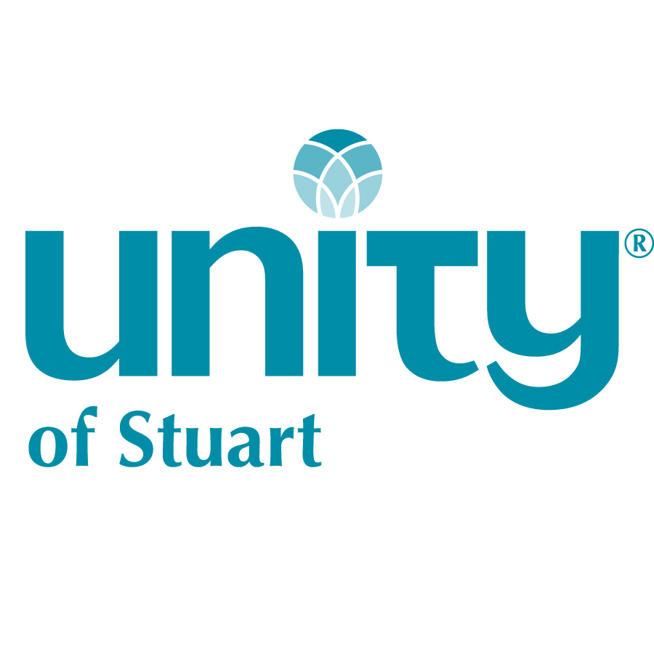

Join Rev. Jude for
Unity Basics

A three-week foundational Unity Class
Sept. 13, 20 & 27

Thursdays 6:30 – 8:30 p.m.

Come join us as we explore the History and Principles
that make Unity “Practical Spirituality”

Completion of this class qualifies you to apply for
membership at Unity of Stuart

Offered for Credentialing Credit
$10 suggested love offering per class

Everyone is welcome regardless of ability to donate.
Please sign up at Information Table

Questions?
Email revjude@unityofstuart.org

